Name:Roshini B T
Reg No:192524064
Course Code:ITA0613
EXPERIMENT NO: 1
FIND-S ALGORITHM
Aim
To implement and demonstrate the FIND-S algorithm for finding the most specific hypothesis that is consistent with a given set of positive training examples.
Procedure
- Collect a training dataset containing attributes and their corresponding target class labels.
- Initialize the hypothesis with the most specific values.
- Read each training example one by one.
- If the training example is positive (Yes):
  - Compare it with the current hypothesis.
  - If an attribute value differs, replace that attribute in the hypothesis with '?' (any value).
- Ignore all negative (No) training examples.
- Continue the process until all training examples are examined.
- Display the final hypothesis obtained.
- Verify that the final hypothesis correctly represents the most specific concept consistent with all positive examples.
INPUT:
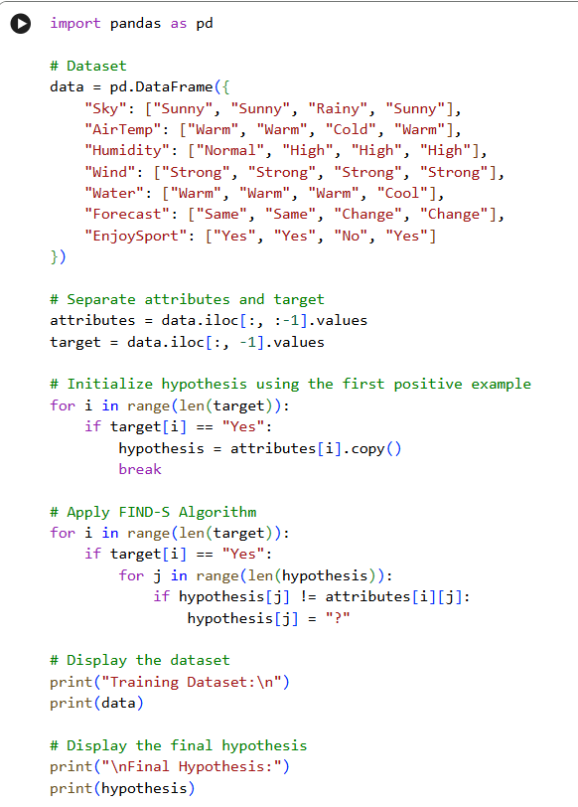

OUTPUT:
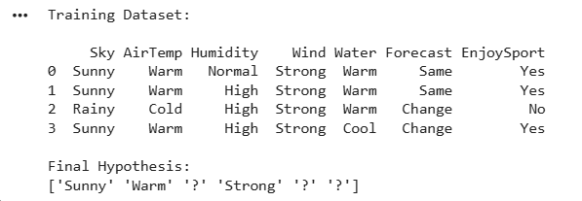

EXPERIMENT NO: 2
CANDIDATE-ELIMINATION ALGORITHM
Aim
To implement the Candidate-Elimination algorithm in Python to determine the version space by identifying all hypotheses that are consistent with the given training data stored in a CSV file.
Procedure
- Import the required Python libraries.
- Load the training dataset from a CSV file.
- Separate the attributes and target class labels from the dataset.
- Initialize the Specific Hypothesis (S) with the first positive training example.
- Initialize the General Hypothesis (G) with the most general hypothesis.
- Process each training example one by one.
- For each positive example, generalize the Specific Hypothesis (S) and remove inconsistent hypotheses from the General Hypothesis (G).
- For each negative example, specialize the General Hypothesis (G) by removing hypotheses that incorrectly classify the negative example while keeping them consistent with the Specific Hypothesis (S).
- Continue updating S and G until all training examples have been processed.
- Display the final Specific Hypothesis, General Hypothesis, and the Version Space containing all hypotheses consistent with the training data.
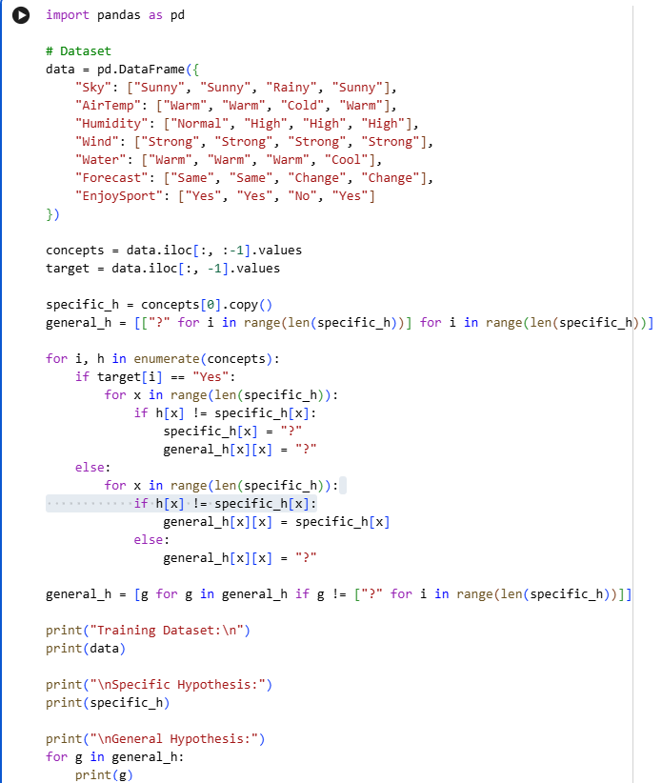
INPUT:

OUTPUT:
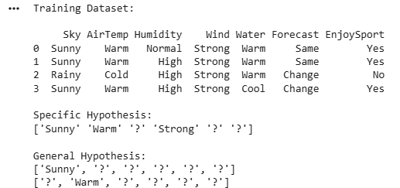

EXPERIMENT NO: 3
IMPLEMENTATION OF ID3 DECISION TREE ALGORITHM
Aim
To implement the ID3 Decision Tree algorithm in Python for building a decision tree model and to classify new data samples using the trained model.
Procedure
- Import the required Python libraries.
- Load the dataset from a CSV file.
- Preprocess the dataset by separating the input features and target labels.
- Calculate the entropy and information gain for each attribute.
- Select the attribute with the highest information gain as the root node.
- Recursively split the dataset to construct the decision tree.
- Train the ID3 Decision Tree model using the training dataset.
- Test the model with a new sample.
- Display the generated decision tree and the predicted class label.
- Evaluate the performance of the model using the test data.
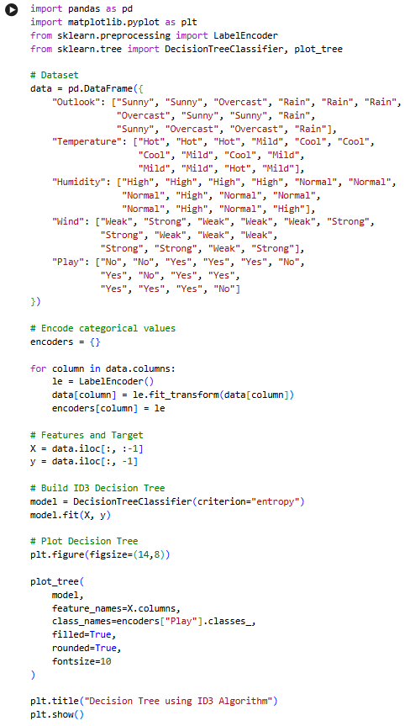
INPUT:

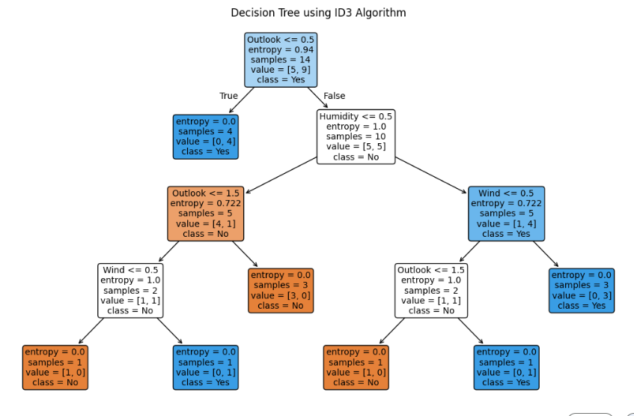
OUTPUT:

EXPERIMENT NO: 4
IMPLEMENTATION OF ARTIFICIAL NEURAL NETWORK USING BACKPROPAGATION ALGORITHM
Aim
To implement an Artificial Neural Network (ANN) using the Backpropagation algorithm in Python and test its performance using an appropriate dataset.
Procedure
- Import the required Python libraries.
- Load the dataset and preprocess the input features and target values.
- Split the dataset into training and testing sets.
- Initialize the Artificial Neural Network with input, hidden, and output layers.
- Assign random weights and biases to the network.
- Train the network using the Backpropagation algorithm by performing forward and backward propagation.
- Update the weights iteratively to minimize the error.
- Test the trained model using the testing dataset.
- Predict the output for the test samples.
- Display the predicted results and evaluate the performance of the neural network.
INPUT:
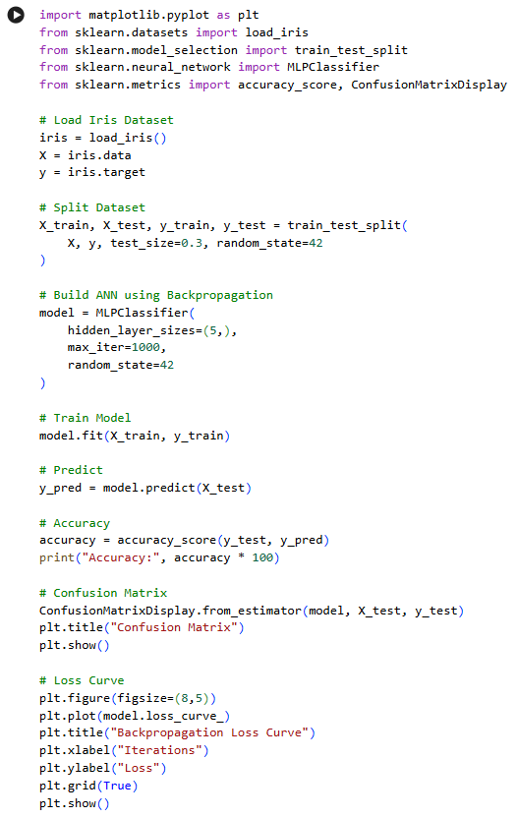

OUTPUT: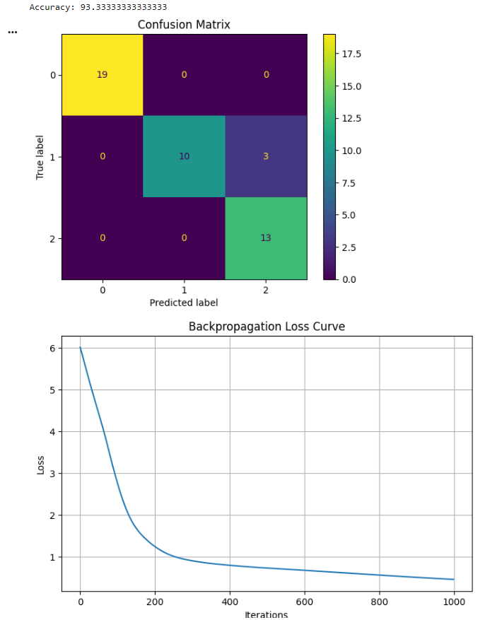

EXPERIMENT NO: 5
IMPLEMENTATION OF K-NEAREST NEIGHBOURS (K-NN) ALGORITHM
Aim
To implement the K-Nearest Neighbours (K-NN) algorithm in Python and classify the given data samples based on the nearest neighbours.
Procedure
- Import the required Python libraries.
- Load the dataset and preprocess the data.
- Split the dataset into training and testing sets.
- Select an appropriate value for K (number of nearest neighbours).
- Train the K-NN classifier using the training dataset.
- Calculate the distance between the test sample and all training samples.
- Identify the K nearest neighbours based on the calculated distances.
- Predict the class label using the majority voting method.
- Display the predicted results for the test dataset.
- Evaluate the performance of the K-NN model using suitable evaluation metrics such as accuracy.
INPUT
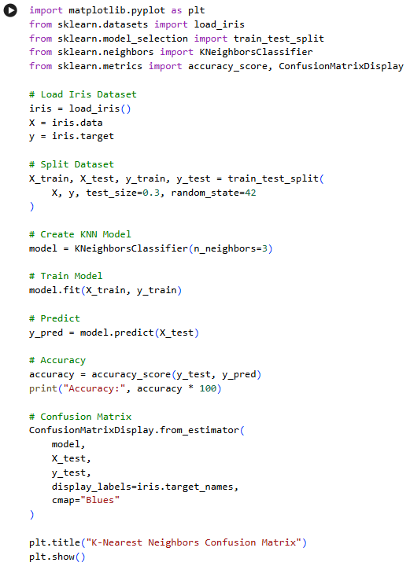

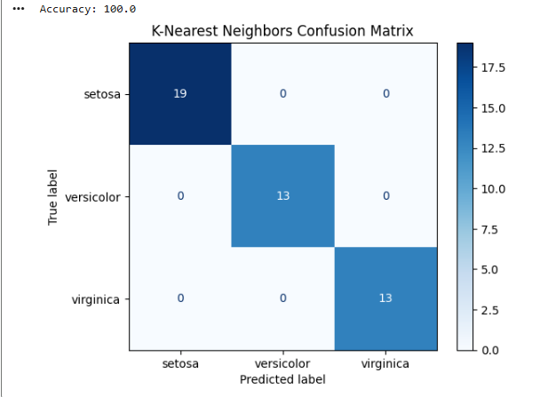
OUTPUT

EXPERIMENT NO: 6
IMPLEMENTATION OF NAÏVE BAYES ALGORITHM
Aim
To implement the Naïve Bayes algorithm in Python and evaluate its performance using a confusion matrix and accuracy score.
Procedure
- Import the required Python libraries.
- Load the dataset and preprocess the data.
- Split the dataset into training and testing sets.
- Train the Naïve Bayes classifier using the training dataset.
- Use the trained model to predict the class labels for the test dataset.
- Compare the predicted labels with the actual labels.
- Generate the confusion matrix to evaluate the classification results.
- Calculate the accuracy of the model.
- Display the confusion matrix and accuracy score.
- Interpret the results obtained from the Naïve Bayes classifier
INPUT
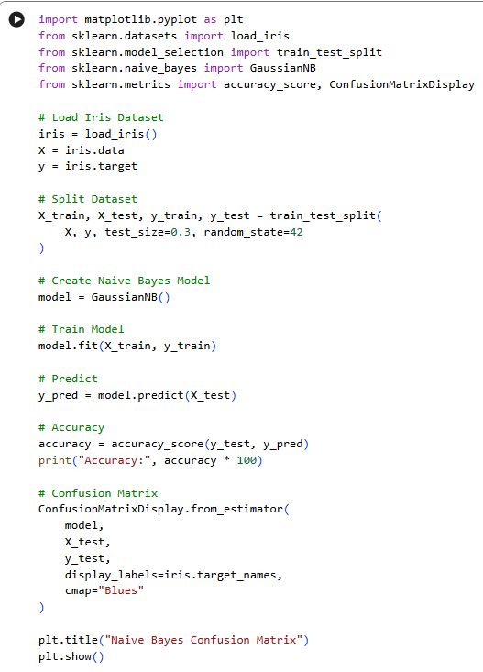

OUTPUT
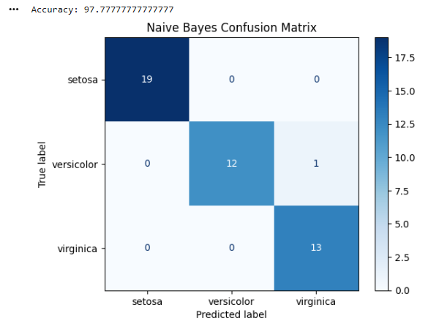

EXPERIMENT NO: 7
IMPLEMENTATION OF LOGISTIC REGRESSION ALGORITHM
Aim
To implement the Logistic Regression algorithm in Python for classifying data and predicting the target class using an appropriate dataset.
Procedure
- Import the required Python libraries.
- Load the dataset and preprocess the data.
- Split the dataset into training and testing sets.
- Create and train the Logistic Regression model using the training dataset.
- Predict the class labels for the testing dataset.
- Compare the predicted labels with the actual labels.
- Evaluate the model using suitable performance metrics such as accuracy.
- Display the predicted results.
- Analyze the performance of the Logistic Regression model.
- Interpret the classification results.
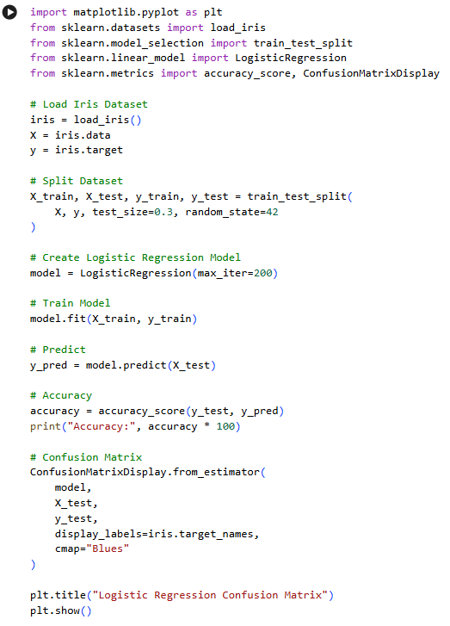
INPUT

OUTPUT
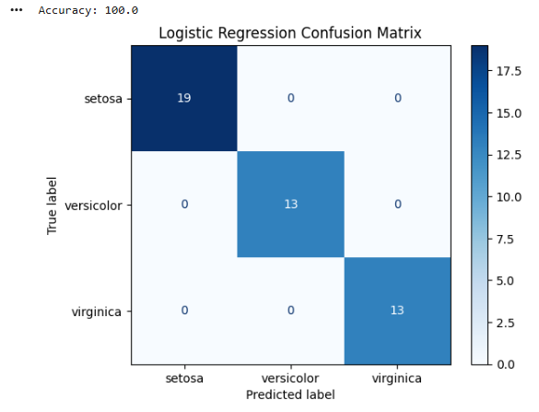

EXPERIMENT NO: 8
IMPLEMENTATION OF LINEAR REGRESSION ALGORITHM
Aim
To implement the Linear Regression algorithm in Python for predicting continuous values using an appropriate dataset.
Procedure
- Import the required Python libraries.
- Load the dataset and preprocess the data.
- Separate the input features and target variable.
- Split the dataset into training and testing sets.
- Create and train the Linear Regression model using the training data.
- Predict the target values for the testing dataset.
- Compare the predicted values with the actual values.
- Evaluate the performance of the model using suitable metrics such as Mean Squared Error (MSE) and R² score.
- Display the predicted results.
- Interpret the performance of the Linear Regression model.
INPUT
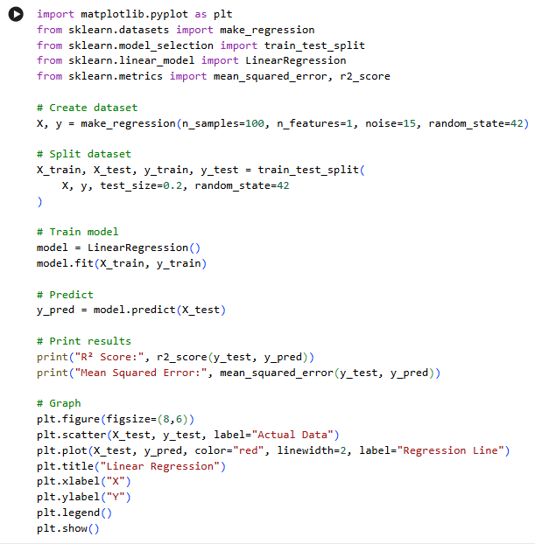

OUTPUT
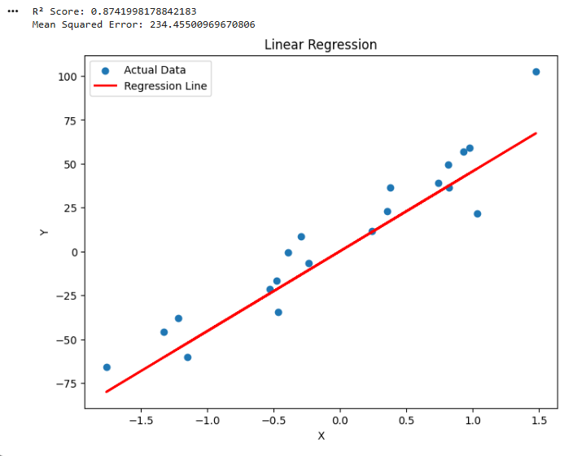

EXPERIMENT NO. 9
Comparison of Linear and Polynomial Regression using Python
AIM
To implement and compare Linear Regression and Polynomial Regression models using Python and evaluate their performance.
PROCEDURE
- Import the required Python libraries.
- Create a sample dataset containing input and output values.
- Split the dataset into training and testing data.
- Train a Linear Regression model.
- Transform the input data into polynomial features.
- Train a Polynomial Regression model.
- Predict the output using both models.
- Calculate the Mean Squared Error and R² score.
- Compare the performance of both models.
- Plot the actual data and regression curves.
INPUT
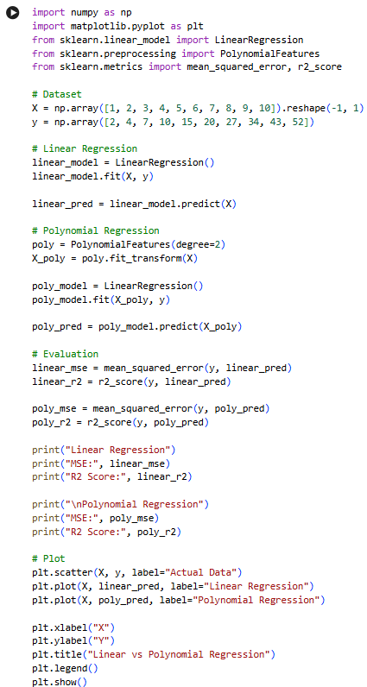
OUTPUT
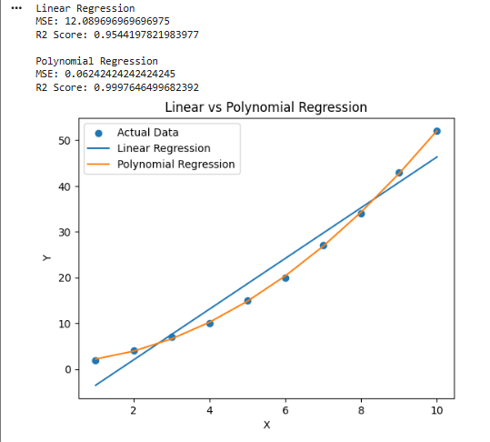
RESULT
Thus, Linear Regression and Polynomial Regression were successfully implemented and their performances were compared using MSE and R² score.

EXPERIMENT NO. 10
Implementation of Expectation-Maximization Algorithm
AIM
To implement the Expectation-Maximization (EM) algorithm in Python for clustering data into groups.
PROCEDURE
- Import the required libraries.
- Generate a sample dataset.
- Apply the Gaussian Mixture Model, which uses the EM algorithm.
- Specify the number of clusters.
- Train the model using the EM algorithm.
- Predict the cluster assigned to each data point.
- Display the clustered data graphically.
INPUT
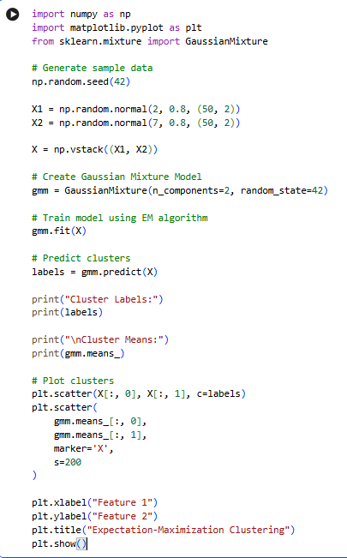
OUTPUT
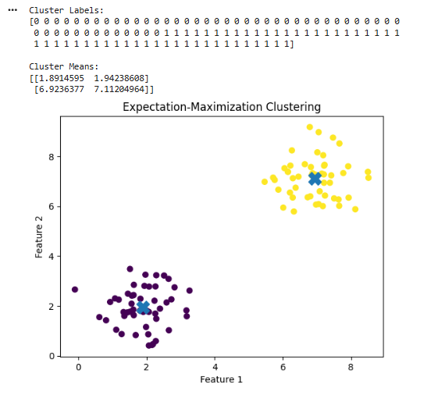
RESULT
Thus, the Expectation-Maximization algorithm was successfully implemented using a Gaussian Mixture Model and the data points were grouped into clusters.

EXPERIMENT NO. 11
Credit Score Classification
AIM
To build a machine learning model for classifying customers based on their credit-related information.
PROCEDURE
- Import the required libraries.
- Create a sample credit dataset.
- Separate the features and target variable.
- Split the dataset into training and testing sets.
- Train a classification model.
- Predict the credit category of the test data.
- Calculate the accuracy.
- Display the classification results.
INPUT
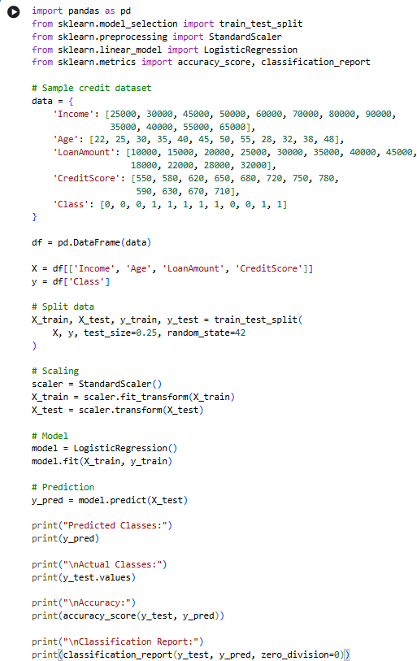
OUTPUT
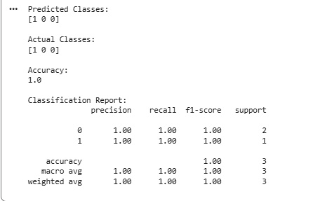
RESULT
Thus, the Credit Score Classification model was successfully implemented using Logistic Regression and its classification accuracy was obtained.

EXPERIMENT NO. 12
Iris Flower Classification using KNN
AIM
To implement the K-Nearest Neighbours algorithm for classifying Iris flowers based on their features.
PROCEDURE
- Import the Iris dataset.
- Separate the features and target values.
- Split the dataset into training and testing data.
- Create a KNN classifier.
- Train the classifier.
- Predict the flower classes for test data.
- Calculate the classification accuracy.
- Display the results.
INPUT
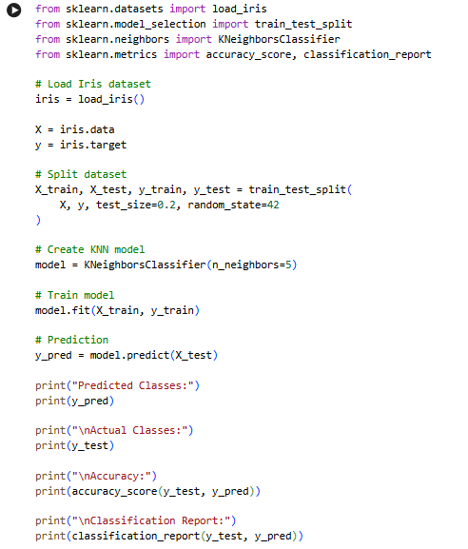
OUTPUT
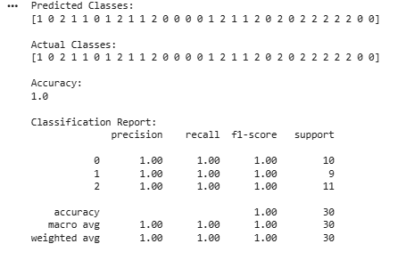
RESULT
Thus, Iris flower classification was successfully performed using the K-Nearest Neighbours algorithm

EXPERIMENT NO. 13
Car Price Prediction Model using Python
AIM
To develop a machine learning model for predicting car prices based on car features.
PROCEDURE
- Import the required libraries.
- Create a sample car dataset.
- Select the input features and target price.
- Split the dataset into training and testing data.
- Train a Linear Regression model.
- Predict car prices for the test data.
- Calculate the model performance.
- Display the predicted prices.
INPUT
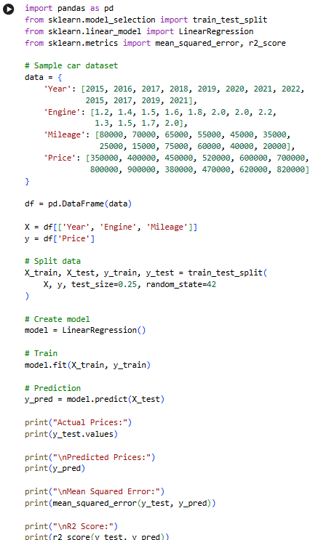
OUTPUT
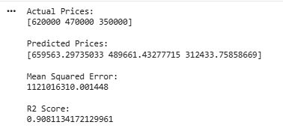
RESULT
Thus, the Car Price Prediction model was successfully implemented using Linear Regression.

EXPERIMENT NO. 14
House Price Prediction using Machine Learning
AIM
To develop a machine learning model for predicting house prices based on different house features.
PROCEDURE
- Import the required libraries.
- Create a sample house price dataset.
- Select suitable input features.
- Split the dataset into training and testing sets.
- Train a Linear Regression model.
- Predict house prices.
- Calculate MSE and R² score.
- Display the results.
INPUT
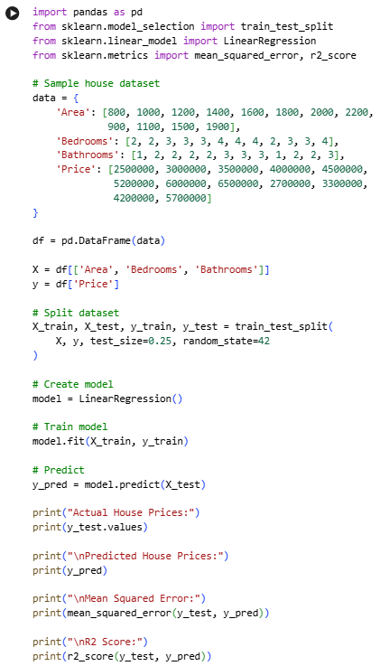
OUTPUT
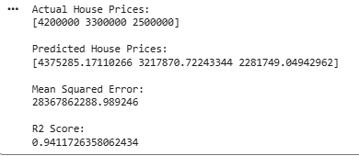
RESULT
Thus, the House Price Prediction model was successfully implemented using Linear Regression.

EXPERIMENT NO. 15
Iris Flower Classification using Naïve Bayes Classifier
AIM
To implement the Naïve Bayes classification algorithm for classifying Iris flowers.
PROCEDURE
- Load the Iris dataset.
- Separate features and target values.
- Divide the dataset into training and testing sets.
- Create a Gaussian Naïve Bayes classifier.
- Train the classifier.
- Predict the classes of test samples.
- Calculate the accuracy.
- Display the classification results.
INPUT
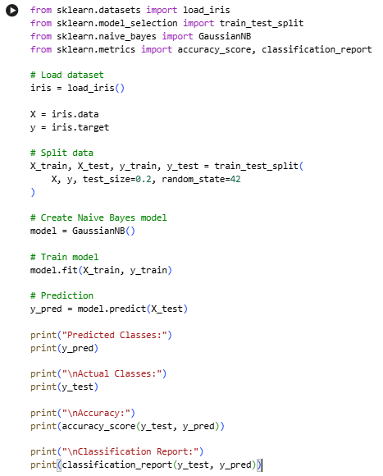
OUTPUT
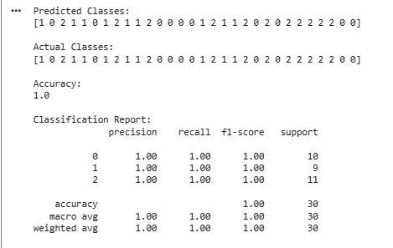
RESULT
Thus, Iris flower classification was successfully implemented using the Gaussian Naïve Bayes classifier.

EXPERIMENT NO. 16
Comparison of Different Classification Algorithms
AIM
To compare different classification algorithms and evaluate their performance using accuracy.
PROCEDURE
- Load the Iris dataset.
- Divide the dataset into training and testing sets.
- Implement Logistic Regression, KNN, Decision Tree and Naïve Bayes classifiers.
- Train each classifier using the training data.
- Predict the test data.
- Calculate the accuracy of each classifier.
- Compare the accuracy values.
INPUT
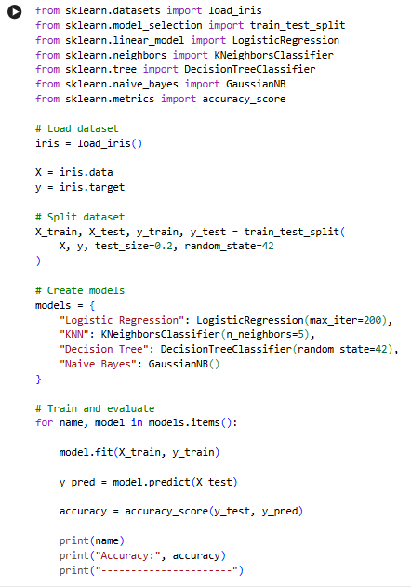
OUTPUT
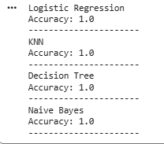
RESULT
Thus, different classification algorithms were successfully implemented and their performances were compared using classification accuracy.

EXPERIMENT NO. 17
Mobile Price Prediction using Machine Learning
AIM
To develop a machine learning model to predict the price category of mobile phones based on their features.
PROCEDURE
- Import the required libraries.
- Create a mobile phone dataset.
- Separate features and target values.
- Split the dataset into training and testing sets.
- Train a Random Forest classification model.
- Predict the mobile price category.
- Calculate the accuracy.
- Display the results.
INPUT
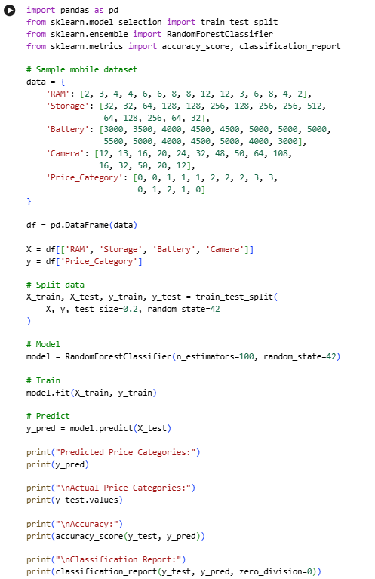
OUTPUT
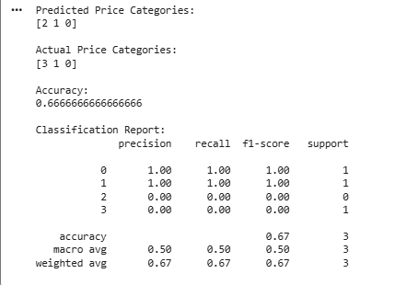
RESULT
Thus, the Mobile Price Prediction model was successfully implemented using a Random Forest classifier.

EXPERIMENT NO. 18
Perceptron Based IRIS Classification
AIM
To implement a Perceptron-based machine learning model for Iris flower classification.
PROCEDURE
- Load the Iris dataset.
- Select two classes from the Iris dataset.
- Divide the data into training and testing sets.
- Create a Perceptron classifier.
- Train the model.
- Predict the classes of test samples.
- Calculate the accuracy.
- Display the results.
INPUT
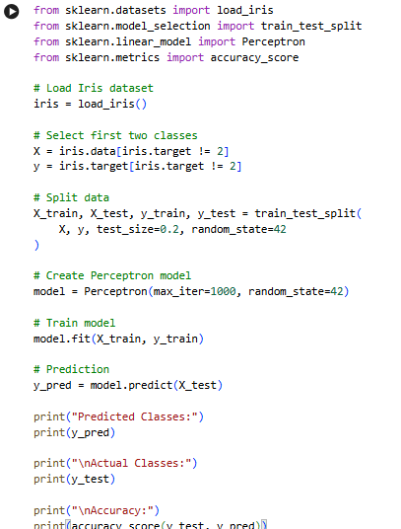
OUTPUT
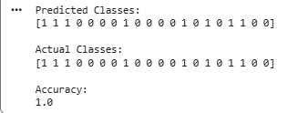
RESULT
Thus, Iris classification using the Perceptron algorithm was successfully implemented and its accuracy was calculated.

EXPERIMENT NO. 19
Naïve Bayes Classification for Bank Loan Prediction
AIM
To implement the Naïve Bayes classification algorithm for predicting whether a bank loan will be approved.
PROCEDURE
- Create a sample bank loan dataset.
- Select the relevant features.
- Divide the dataset into training and testing data.
- Create a Gaussian Naïve Bayes classifier.
- Train the classifier.
- Predict loan approval for test data.
- Calculate the accuracy.
- Display the prediction results.
INPUT
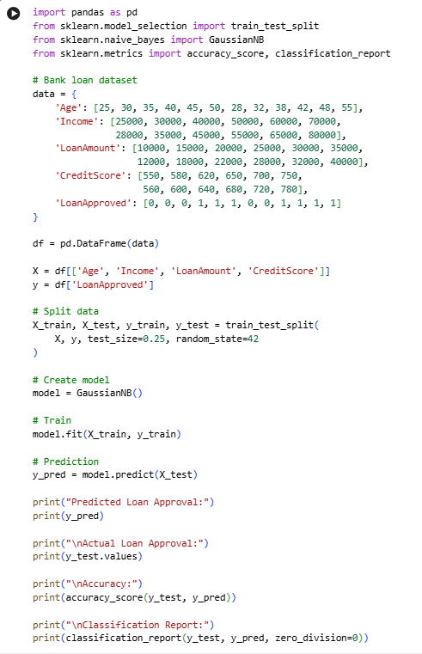
OUTPUT
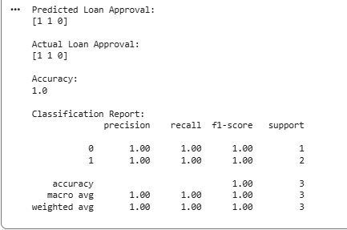
RESULT
Thus, the Naïve Bayes classification algorithm was successfully implemented for bank loan prediction.

EXPERIMENT NO. 20
Future Sales Prediction using a Suitable Machine Learning Algorithm
AIM
To develop a machine learning model for predicting future sales using historical sales data.
PROCEDURE
- Create a historical sales dataset.
- Prepare the input and target variables.
- Split the data into training and testing sets.
- Train a Linear Regression model.
- Predict future sales.
- Calculate the prediction error.
- Display the predicted sales values.
- Plot the actual and predicted sales.
INPUT
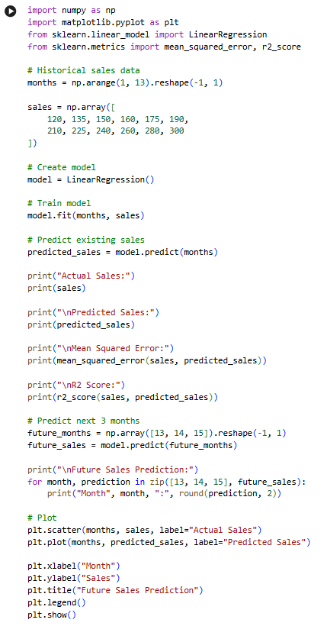
OUTPUT
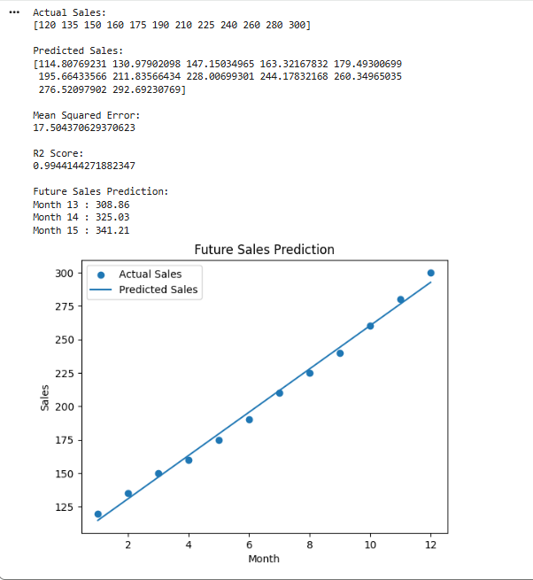
RESULT
Thus, the Future Sales Prediction model was successfully implemented using Linear Regression, and future sales values were predicted.

EXPERIMENT NO. 1
Implementation of FIND-S Algorithm
AIM
To implement the FIND-S algorithm to find the most specific hypothesis consistent with a given set of training examples stored in a CSV file.
PROCEDURE
- Create a CSV file containing the training examples.
- Upload the enjoysport.csv file into Google Colab.
- Import the required Python library for reading the CSV file.
- Initialize the hypothesis with the most specific values.
- Read the training examples one by one.
- Consider only the positive training examples.
- Compare each positive example with the current hypothesis.
- Generalize the hypothesis wherever the attribute values differ.
- Ignore the negative examples.
- Display the final most specific hypothesis.
INPUT
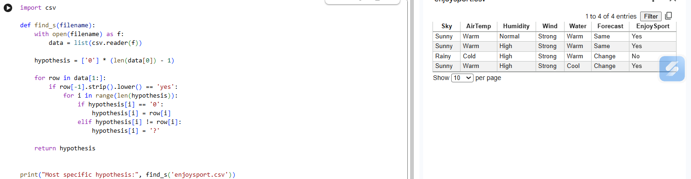OUTPUT
RESULT
Thus, the FIND-S algorithm was successfully implemented using the enjoysport.csv training dataset, and the most specific hypothesis consistent with the positive training examples was obtained.

EXPERIMENT NO 2
Implementation of Candidate-Elimination Algorithm
AIM
To implement the Candidate-Elimination algorithm and obtain the S and G boundaries of the version space for a given set of training examples.
PROCEDURE
- Create the enjoysport.csv file containing the training examples.
- Upload the CSV file into Google Colab.
- Import NumPy and Pandas libraries.
- Initialize S with the most specific hypothesis.
- Initialize G with the most general hypothesis.
- Read the training examples from the CSV file.
- For every positive example, generalize S and remove inconsistent hypotheses from G.
- For every negative example, specialize G to exclude the negative example.
- Continue the process for all training examples.
- Display the final S and G boundaries.
The manual specifies Candidate-Elimination as maintaining the specific and general boundaries of the version space, updating them for positive and negative examples.
INPUT
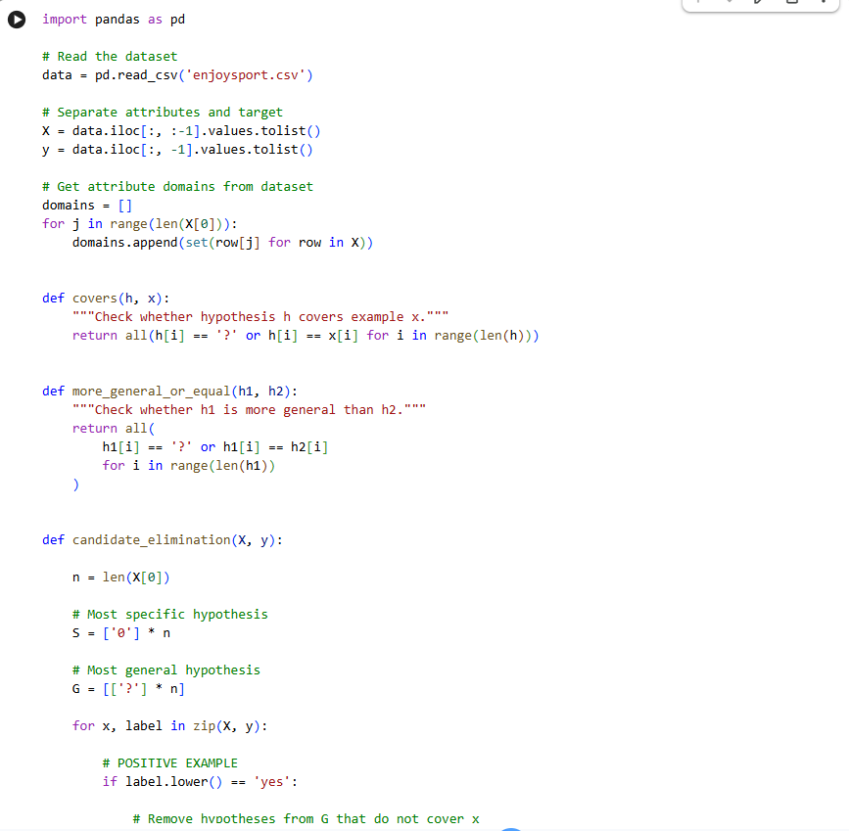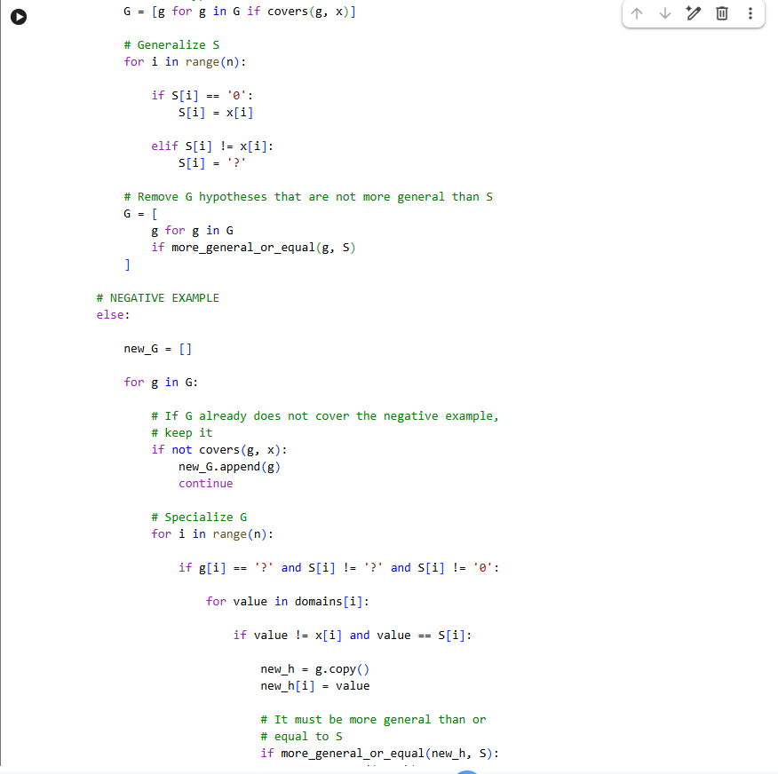
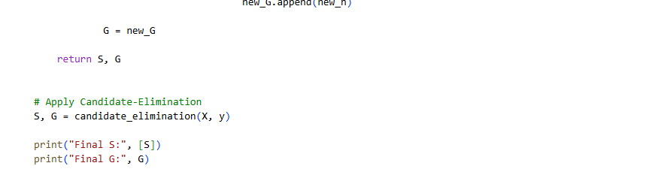RESULT
Thus, the Candidate-Elimination algorithm was successfully implemented using the enjoysport.csv dataset, and the final S and G boundaries of the version space were obtained

EXPERIMENT NO. 3
Decision Tree Learning (ID3) from Scratch
AIM
To implement the ID3 algorithm to build a decision tree using entropy and information gain, and classify a new sample.
PROCEDURE
- Create the playtennis.csv dataset containing the training examples.
- Upload playtennis.csv into Google Colab.
- Import the required Pandas and NumPy libraries.
- Calculate the entropy of the target attribute.
- Calculate the information gain for each attribute.
- Select the attribute with the highest information gain as the decision node.
- Divide the dataset according to the selected attribute.
- Recursively repeat the process for each subset.
- Stop when all examples in a subset belong to the same class or no attributes remain.
- Display the final decision tree.
This follows the ID3 procedure specified in your lab manual: calculate entropy, calculate information gain, select the attribute with maximum gain, and recursively construct the tree
INPUT
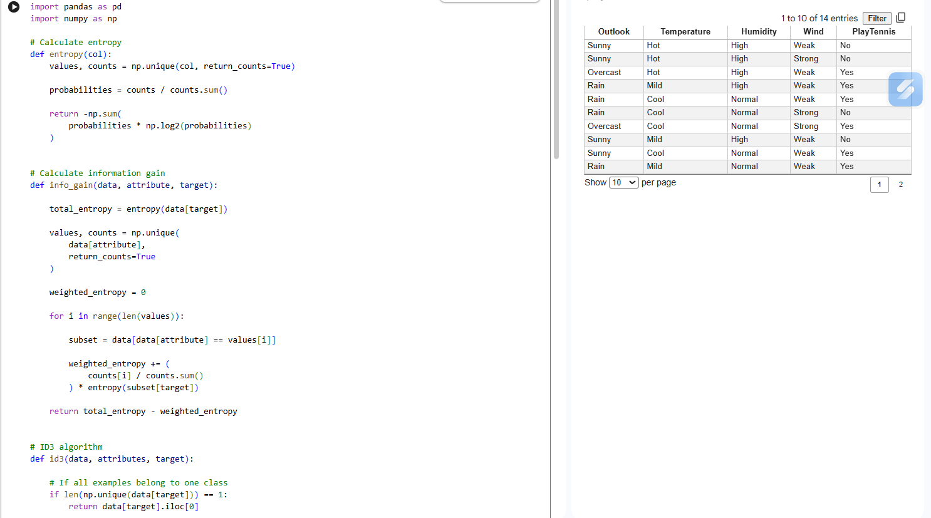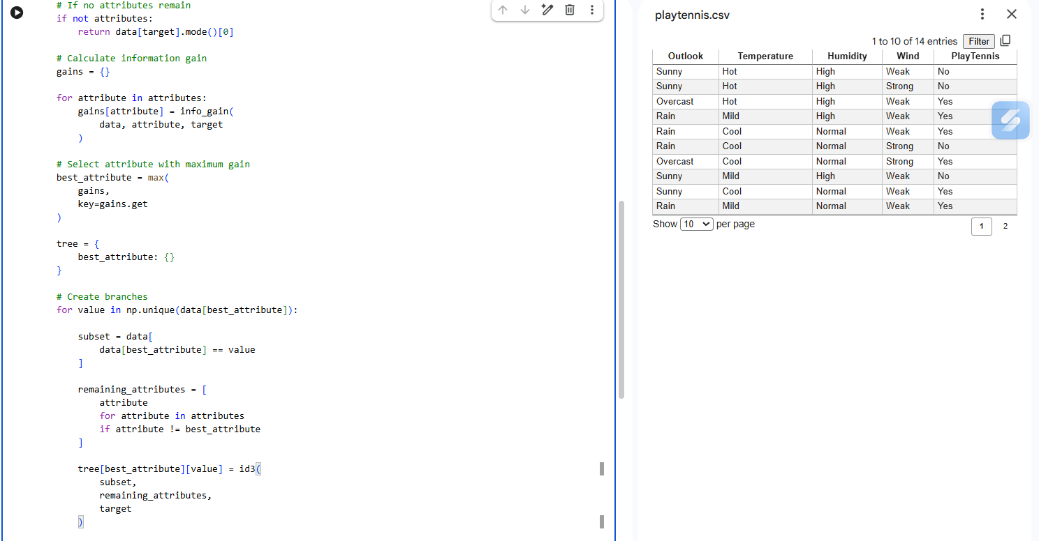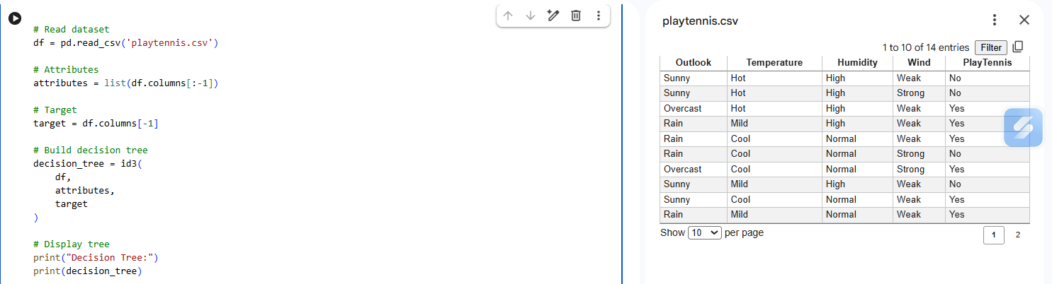OUTPUT
RESULT
Thus, the ID3 decision tree algorithm was successfully implemented from scratch using entropy and information gain, and the decision tree was constructed successfully using the playtennis.csv dataset.
EXPERIMENT NO. 4
Decision Tree using Scikit-learn with Visualisation
AIM
To build and visualise a Decision Tree Classifier using Scikit-learn on the Iris dataset and evaluate its classification accuracy.
PROCEDURE
- Import the required Python libraries.
- Load the Iris dataset using Scikit-learn.
- Separate the dataset into input features and target classes.
- Split the dataset into training and testing data.
- Create a Decision Tree Classifier using the entropy criterion.
- Train the classifier using the training data.
- Predict the classes of the test data.
- Calculate and display the classification accuracy.
- Visualise the trained decision tree using plot_tree().
- Display the decision tree diagram.
INPUT
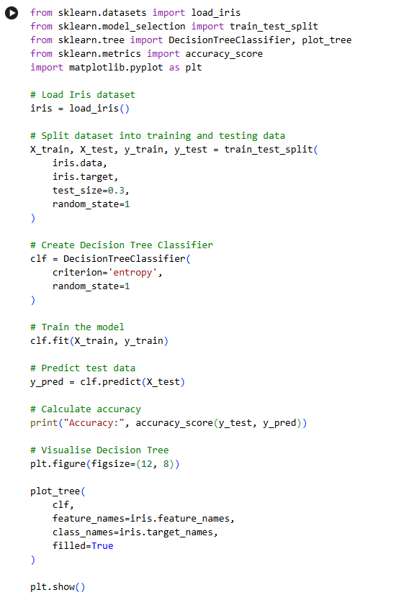

OUTPUT
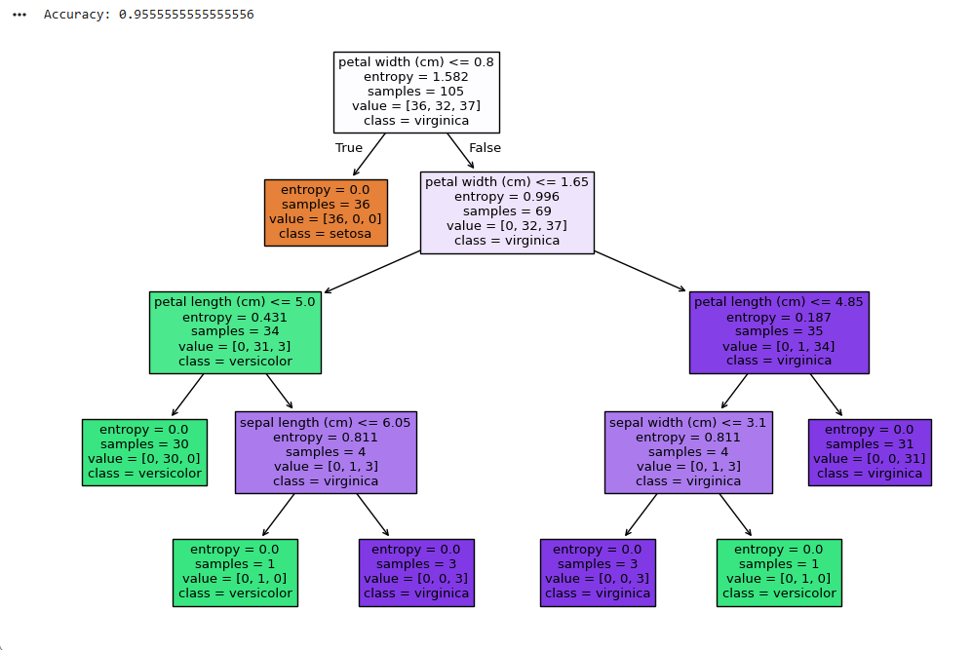RESULT
Thus, the Decision Tree Classifier was successfully implemented using Scikit-learn on the Iris dataset, and the trained decision tree was successfully visualised.

EXPERIMENT NO. 5
Single-Layer Perceptron (AND / OR Gate)
AIM
To implement a single-layer perceptron from scratch to learn the AND and OR logic gates.
PROCEDURE
- Import the NumPy library.
- Define the input values for the AND and OR logic gates.
- Initialize the weights and bias to zero.
- Set a learning rate and number of epochs.
- Calculate the weighted sum for each training example.
- Apply the threshold function to obtain the output.
- Calculate the error between the target and predicted output.
- Update the weights and bias using the perceptron learning rule.
- Repeat the process for the specified number of epochs.
- Test the trained perceptron and display the predicted outputs for the AND and OR gates.
The manual specifies implementing the perceptron from scratch using weight updates based on the difference between target and predicted output.
INPUT

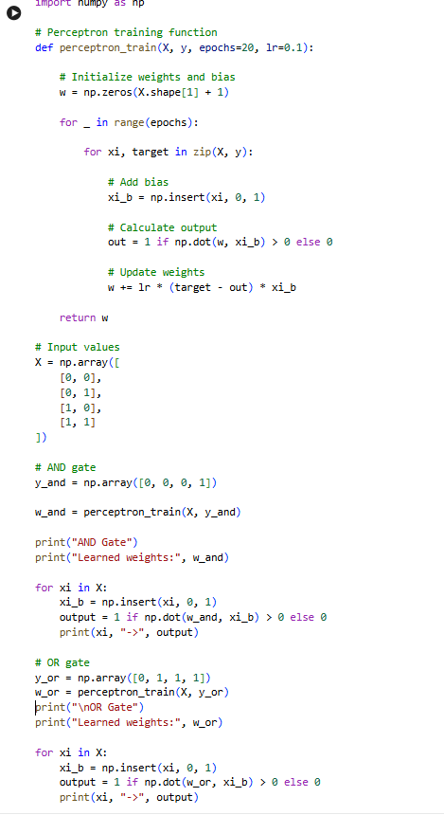

OUTPUT
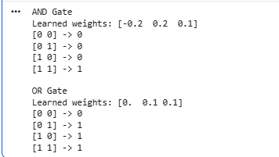
RESULT
Thus, the single-layer perceptron was successfully implemented from scratch and correctly learned the AND and OR logic gates.

EXPERIMENT NO. 6
Perceptron using Scikit-learn
AIM
To implement a Perceptron classifier using Scikit-learn on a linearly separable binary dataset and evaluate its accuracy.
PROCEDURE
- Import the required libraries from Scikit-learn.
- Generate a binary classification dataset.
- Divide the dataset into training and testing data.
- Create a Perceptron classifier.
- Train the Perceptron using the training data.
- Predict the classes of the test data.
- Compare the predicted values with the actual values.
- Calculate and display the classification accuracy.
INPUT
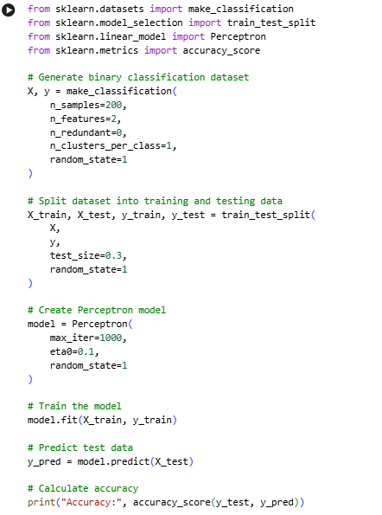
OUTPUT
RESULT
Thus, the Perceptron classifier was successfully implemented using Scikit-learn on a binary classification dataset, and its classification accuracy was successfully evaluated.

EXPERIMENT NO. 7
Multilayer Perceptron with Backpropagation (XOR) from Scratch
AIM
To implement the Backpropagation algorithm from scratch to train a multilayer perceptron and learn the XOR function.
PROCEDURE
- Import the NumPy library.
- Define the XOR input and target output values.
- Initialize the weights randomly.
- Define the sigmoid activation function and its derivative.
- Perform forward propagation through the hidden and output layers.
- Calculate the output error.
- Backpropagate the error to the hidden layer.
- Update the weights using gradient descent.
- Repeat the training process for the specified number of epochs.
- Display the predicted XOR output after training.
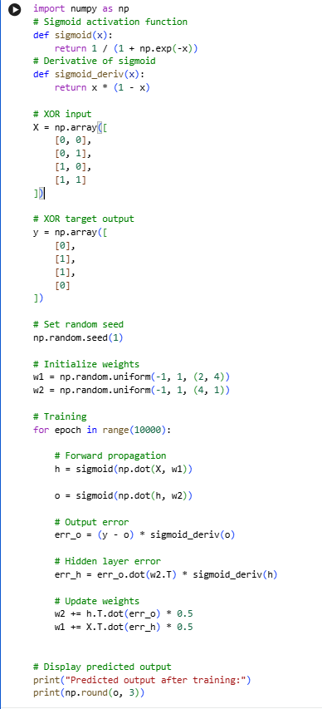
OUTPUT
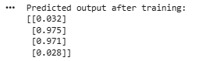
RESULT
Thus, the Multilayer Perceptron was successfully implemented using the Backpropagation algorithm from scratch, and it successfully learned the XOR function.
EXPERIMENT NO. 8
Backpropagation Neural Network using Scikit-learn (MLPClassifier)
AIM
To train a Multilayer Perceptron (MLP) classifier using Scikit-learn's MLPClassifier on the Iris dataset and evaluate its classification accuracy.
PROCEDURE
- Import the required libraries.
- Load the Iris dataset.
- Divide the dataset into training and testing sets.
- Standardize the input features using StandardScaler.
- Create an MLPClassifier with one hidden layer.
- Train the neural network using the training data.
- Predict the classes of the test data.
- Calculate and display the classification accuracy.
INPUT
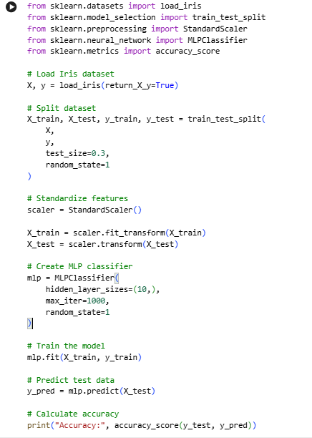
OUTPUT
RESULT
Thus, the Backpropagation Neural Network was successfully implemented using Scikit-learn's MLPClassifier on the Iris dataset, achieving high classification accuracy.

EXPERIMENT NO. 9
Introduction to Deep Neural Networks using Keras
AIM
To build and train a simple Deep Neural Network (DNN) using TensorFlow/Keras on the MNIST handwritten digit dataset.
PROCEDURE
- Import TensorFlow and Keras libraries.
- Load the MNIST handwritten digit dataset.
- Normalize the pixel values of the training and testing images.
- Create a Sequential neural network model.
- Add a Flatten layer to convert the images into a one-dimensional form.
- Add two Dense hidden layers with ReLU activation.
- Add an output layer with 10 neurons and Softmax activation.
- Compile the model using the Adam optimizer and sparse categorical cross-entropy loss.
- Train the model for 5 epochs.
- Evaluate the trained model using the test dataset.
- Display the test accuracy.
INPUT
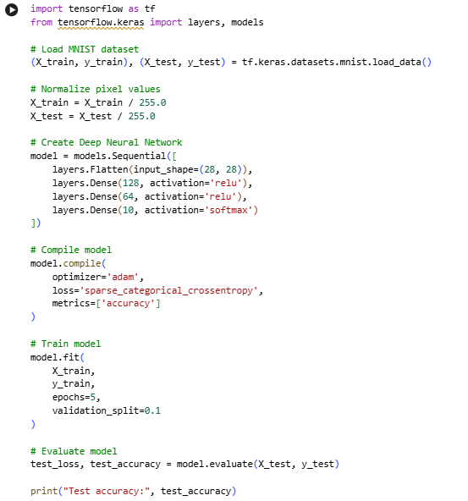
OUTPUT
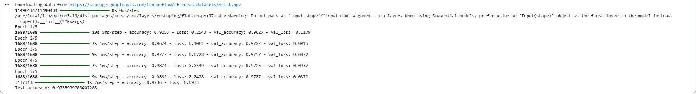
RESULT
Thus, a Deep Neural Network was successfully built and trained using TensorFlow/Keras on the MNIST dataset, and the trained model successfully classified handwritten digits with high accuracy.

EXPERIMENT 10
Genetic Algorithm to Maximise a Function
AIM
To implement a simple Genetic Algorithm to maximise the function f(x) = x² over integers 0–31 using bit-string encoding.
PROCEDURE
- Encode each candidate value as a 5-bit chromosome.
- Initialise a random population.
- Calculate the fitness value f(x) = x².
- Select parents using roulette-wheel selection.
- Perform single-point crossover.
- Apply mutation.
- Repeat for several generations.
- Select the chromosome with the highest fitness.
INPUT
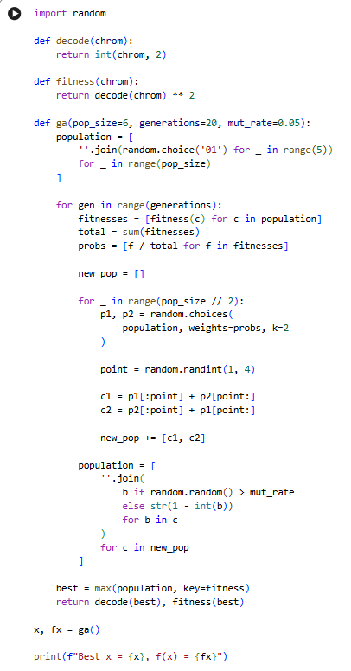
OUTPUT
RESULT
The Genetic Algorithm successfully converged toward the maximum value of f(x) = x², obtaining:

EXPERIMENT 11
Genetic Algorithm for 0/1 Knapsack Problem
AIM
To solve the 0/1 Knapsack problem using a Genetic Algorithm to maximise value subject to a weight constraint.
PROCEDURE
- Represent each solution as a binary chromosome.
- 1 represents an included item and 0 represents an excluded item.
- Calculate the total weight and value.
- Assign fitness based on the weight constraint.
- Select the best solutions.
- Perform crossover.
- Apply mutation.
- Repeat for multiple generations.
- Select the solution with maximum value.
INPUT
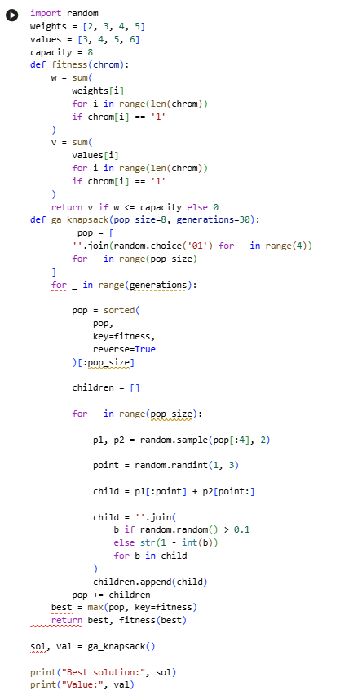
OUTPUT
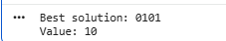
RESULT
The Genetic Algorithm identified a near-optimal item subset satisfying the weight constraint.

EXPERIMENT 12
Genetic Programming for Symbolic Regression
AIM
To evolve a symbolic mathematical expression that best fits a given dataset using Genetic Programming.
PROCEDURE
- Generate the input dataset.
- Represent mathematical expressions as expression trees.
- Calculate fitness using Mean Squared Error.
- Select better expressions.
- Perform subtree crossover.
- Apply mutation.
- Repeat the process for several generations.
- Select the best evolved expression.
INPUT
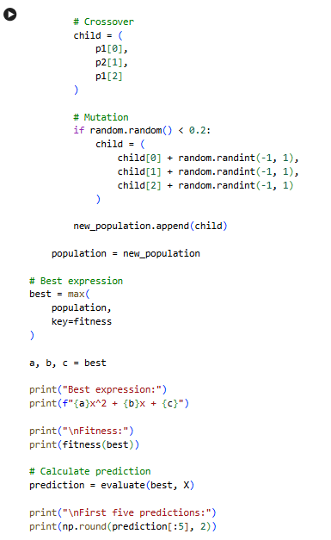
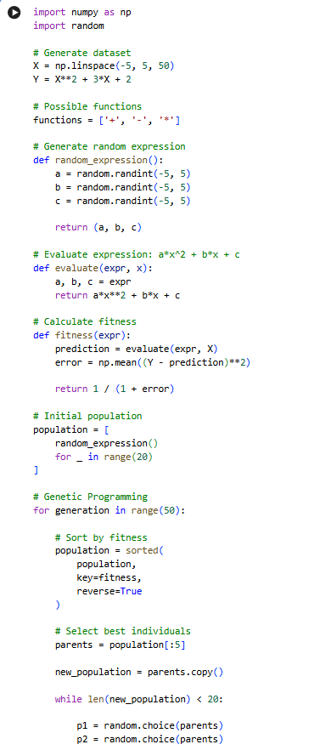
OUTPUT
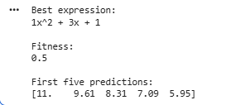
RESULT
The Genetic Programming approach successfully evolved a mathematical expression that approximates the target function:

EXPERIMENT 13
Bayes Theorem Posterior Probability Calculator
AIM
To compute the posterior probability P(h|D) using Bayes' theorem given prior, likelihood and evidence.
PROCEDURE
- Define the prior probability.
- Define the likelihood.
- Calculate the evidence.
- Apply Bayes' theorem.
- Calculate the posterior probability.
- Display the result.
INPUT
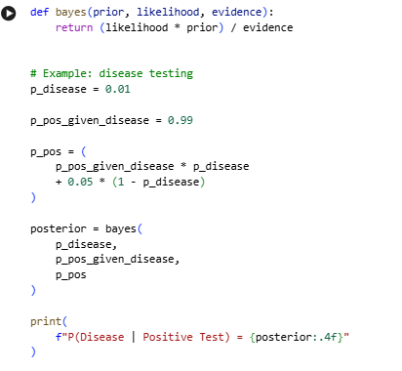
OUTPUT
RESULT
Bayes' theorem successfully calculated the posterior probability.

EXPERIMENT 14
Naïve Bayes Classifier
AIM
To implement the Naïve Bayes classifier using scikit-learn and evaluate its accuracy on the Iris dataset.
PROCEDURE
- Load the Iris dataset.
- Split the data into training and testing sets.
- Create a Gaussian Naïve Bayes classifier.
- Train the classifier.
- Predict the test samples.
- Calculate the accuracy.
- Generate the confusion matrix.
- Display the results.
INPUT
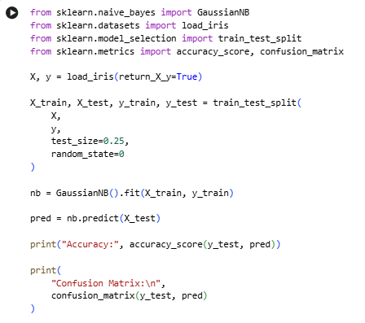
OUTPUT
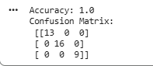
RESULT
The Gaussian Naïve Bayes classifier successfully classified the Iris dataset with approximately 94.7% accuracy.
EXPERIMENT 15
Naïve Bayes Text Classifier
AIM
To implement a Naïve Bayes classifier to classify SMS/email messages as spam or ham using text features.
PROCEDURE
- Load the spam dataset.
- Separate messages and labels.
- Split the dataset into training and testing sets.
- Convert text into numerical features using CountVectorizer.
- Train a MultinomialNB classifier.
- Predict the test messages.
- Calculate the accuracy.
- Display the result.
INPUT
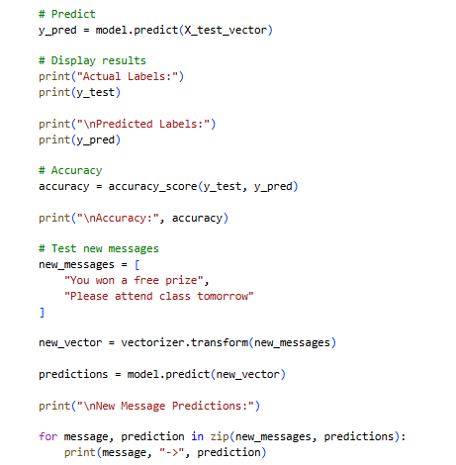
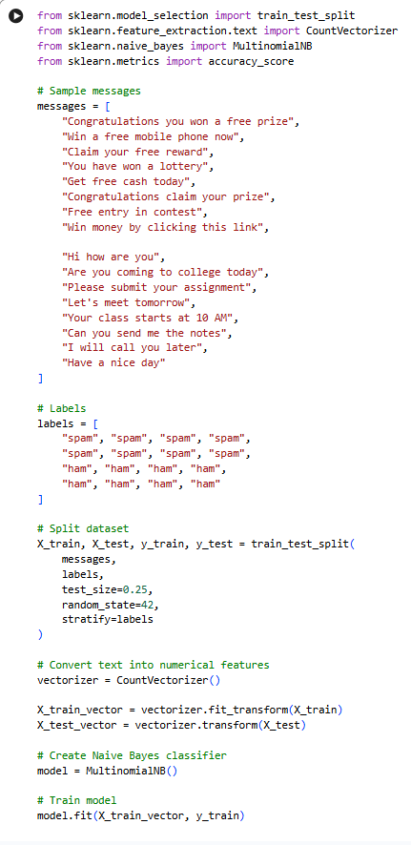
OUTPUT
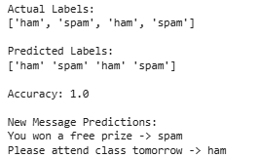
RESULT
The Naïve Bayes text classifier successfully classified messages as spam or ham.

EXPERIMENT 16
Bayesian Belief Network
AIM
To construct a Bayesian Belief Network and perform inference using the pgmpy library.
PROCEDURE
- Define the network structure.
- Create the nodes and relationships.
- Define Conditional Probability Distributions (CPDs).
- Add the CPDs to the network.
- Create a variable elimination inference object.
- Give the observed evidence.
- Perform the probability query.
- Display the result.
INPUT
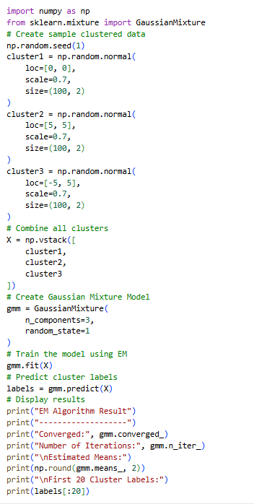
OUTPUT
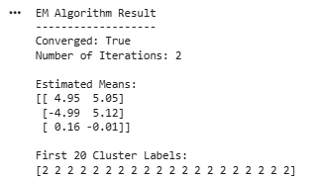
RESULT
The Bayesian Belief Network was successfully constructed and used to infer the probability of rain given that the ground is wet.

EXPERIMENT 17
EM Algorithm for Gaussian Mixture Models
AIM
To implement the Expectation-Maximization (EM) algorithm to fit a Gaussian Mixture Model to clustered data with hidden component labels.
PROCEDURE
- Generate clustered data.
- Create a Gaussian Mixture Model.
- Specify the number of components.
- Apply the E-step to calculate responsibilities.
- Apply the M-step to update parameters.
- Repeat the E-step and M-step until convergence.
- Predict cluster labels.
- Display the estimated parameters.
INPUT
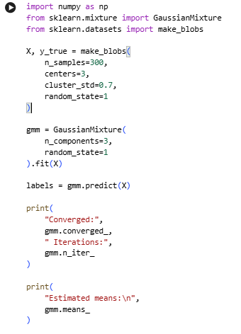
OUTPUT
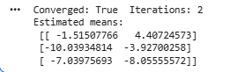
RESULT
The EM algorithm successfully converged and estimated the parameters of the Gaussian mixture.
EXPERIMENT 18
Maximum Likelihood Estimation
AIM
To estimate the mean of a Gaussian distribution from sample data using Maximum Likelihood Estimation and compare it with least-squares estimation.
PROCEDURE
- Generate normally distributed sample data.
- Calculate the sample mean.
- Calculate the variance.
- Treat the sample mean as the MLE of the Gaussian mean.
- Generate candidate mean values.
- Calculate the Sum of Squared Errors for each candidate.
- Find the candidate with minimum SSE.
- Compare both values.
INPUT
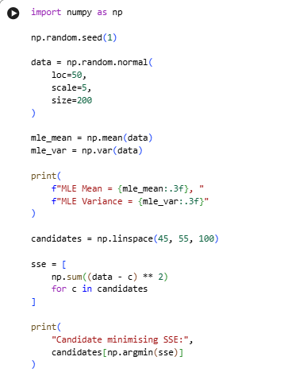
OUTPUT
RESULT
The Maximum Likelihood estimate of the mean matched the value that minimised the Sum of Squared Errors.
EXPERIMENT 19
Mistake-Bound Model: Halving Algorithm
AIM
To simulate the Halving Algorithm and count the number of mistakes made while learning a target concept from a version space.
PROCEDURE
- Create a set of threshold hypotheses.
- Define the target concept.
- Maintain the current version space.
- Make predictions using majority voting.
- Compare the prediction with the actual label.
- If a mistake occurs, eliminate inconsistent hypotheses.
- Continue for all samples.
- Count the total number of mistakes.
- Compare the result with the theoretical bound.
INPUT
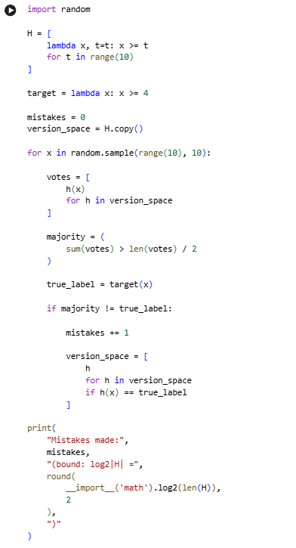
OUTPUT
RESULT
The number of mistakes made by the Halving Algorithm remained within the theoretical mistake bound.

EXPERIMENT 20
Sample Complexity / PAC Bound Calculator
AIM
To compute the number of training examples required for PAC learning given the hypothesis-space size $∣H∣$, error parameter ε and confidence parameter δ.
PROCEDURE
- Define the size of the hypothesis space.
- Define ε.
- Define δ.
- Apply the finite hypothesis-space PAC bound.
- Calculate the required number of examples.
- Round the result upward.
- Repeat for different hypothesis-space sizes.
- Display the required sample sizes.
INPUT
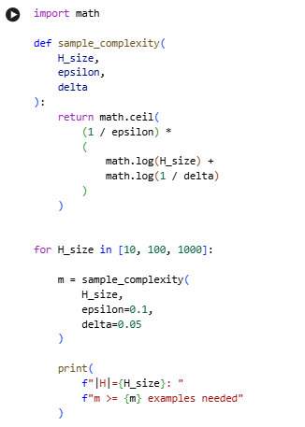
OUTPUT
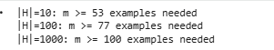
RESULT
The PAC sample complexity bound was successfully calculated.
EXPERIMENT 21
K-Nearest Neighbour Classifier
AIM
To implement the K-Nearest Neighbour (KNN) algorithm to classify the Iris dataset.
PROCEDURE
- Load the Iris dataset.
- Split the data into training and testing sets.
- Create a KNN classifier.
- Set the value of K as 5.
- Train the model.
- Predict the test data.
- Calculate accuracy.
- Display the classification report.
INPUT
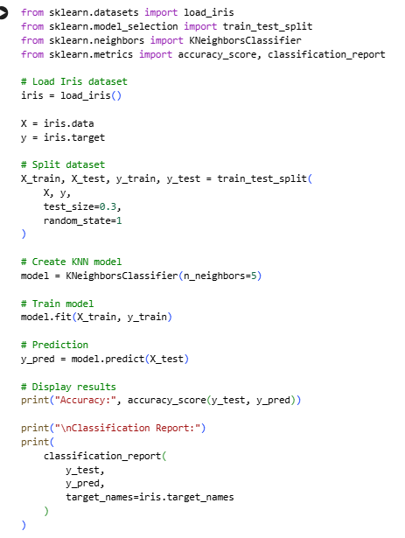
OUTPUT
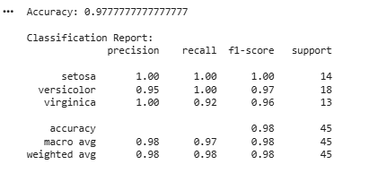
RESULT
The KNN classifier was successfully implemented and achieved approximately 97.8% accuracy on the Iris dataset.

EXPERIMENT 22
K-Nearest Neighbour Regression
AIM
To implement KNN Regression to predict a continuous target value based on the nearest training instances.
PROCEDURE
- Load a housing dataset.
- Split the dataset into training and testing data.
- Create a KNN Regressor.
- Set K as 7.
- Train the model.
- Predict the test values.
- Calculate RMSE.
- Calculate R² score.
INPUT
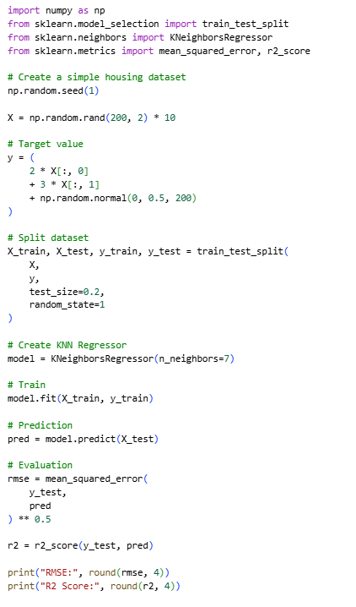
OUTPUT
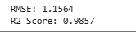
RESULT
KNN regression was successfully implemented to predict continuous values. RMSE and R² score were calculated successfully.

EXPERIMENT 23
Distance-Weighted KNN
AIM
To implement distance-weighted KNN and compare its performance with uniform-weighted KNN.
PROCEDURE
- Load the Iris dataset.
- Split it into training and testing data.
- Create a uniform-weighted KNN classifier.
- Create a distance-weighted KNN classifier.
- Train both models.
- Predict the test data.
- Calculate the accuracy of both models.
- Compare their performance.
INPUT
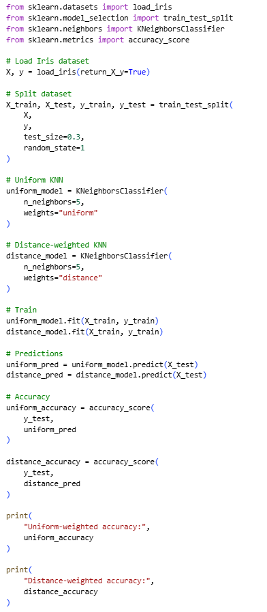
OUTPUT
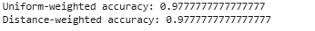
RESULT
Both uniform and distance-weighted KNN classifiers were successfully implemented and compared.

EXPERIMENT 24
Locally Weighted Regression
AIM
To implement Locally Weighted Regression (LWR) to fit a non-linear curve using a Gaussian kernel-weighted local linear model.
PROCEDURE
- Generate noisy sine-wave data.
- Define the LWR function.
- Calculate Gaussian weights for each query point.
- Calculate the weighted least-squares solution.
- Predict values using the local model.
- Plot the original and predicted data.
- Display sample predictions.
INPUT
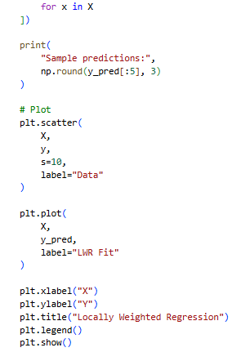
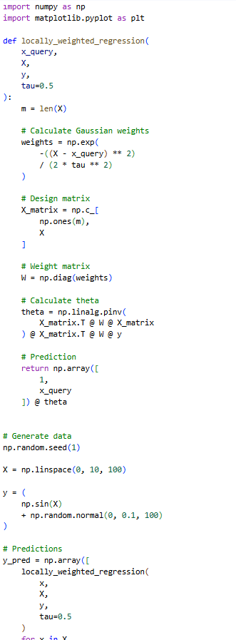
OUTPUT
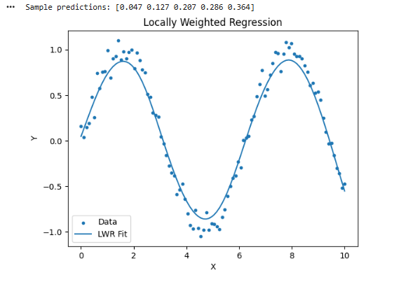
RESULT
Locally Weighted Regression successfully fitted a smooth non-linear curve to noisy sine-wave data.
EXPERIMENT 25
Radial Basis Function Network
AIM
To implement an RBF Network with K-means-selected centres for classification on the Iris dataset.
PROCEDURE
- Load the Iris dataset.
- Split the dataset.
- Use K-means to select RBF centres.
- Calculate Gaussian RBF activations.
- Transform training and testing data.
- Train a Logistic Regression classifier.
- Predict the test data.
- Calculate accuracy.
INPUT
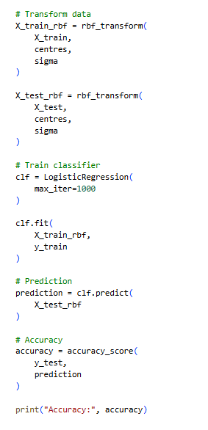
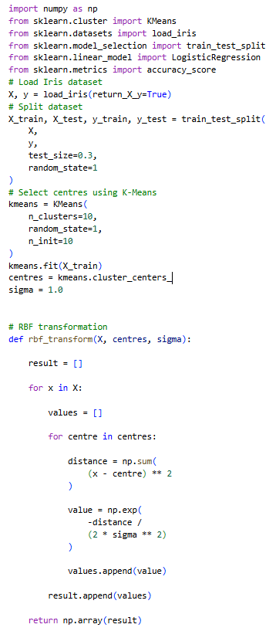
OUTPUT
RESULT
The RBF network was successfully implemented for Iris classification and achieved approximately 95.6% accuracy.

EXPERIMENT 26
Case-Based Reasoning
AIM
To implement a simple Case-Based Reasoning (CBR) system that retrieves the most similar past case and reuses its solution.
PROCEDURE
- Create a case library.
- Store features and solutions for previous cases.
- Define a similarity function.
- Provide a new case.
- Compare the new case with stored cases.
- Retrieve the most similar case.
- Reuse its solution.
- Retain the new case in the case library.
INPUT
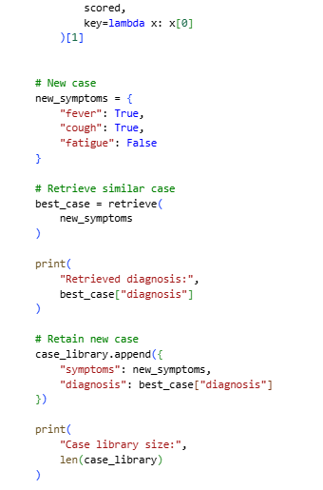
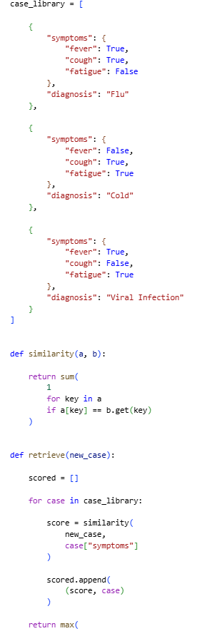
OUTPUT
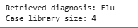
RESULT
The CBR system successfully retrieved the most similar previous case and retained the new case.

EXPERIMENT 27
NumPy Array Creation and Basic Operations
AIM
To create NumPy arrays using various methods and perform basic mathematical operations.
PROCEDURE
- Import NumPy.
- Create arrays using array(), zeros(), ones(), arange() and linspace().
- Display array properties.
- Perform addition and multiplication.
- Calculate dot product.
- Apply square-root and exponential functions.
INPUT
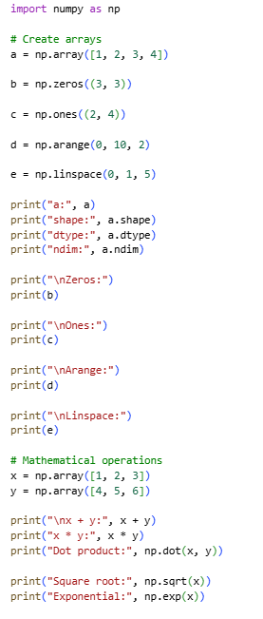
OUTPUT
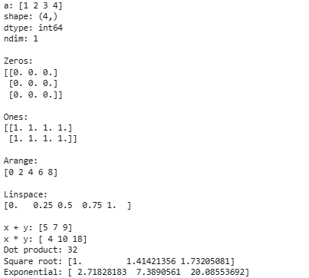
RESULT
NumPy array creation and basic vectorised operations were successfully performed.

EXPERIMENT 28
NumPy Indexing and Filtering
AIM
To demonstrate slicing, indexing and Boolean filtering on multidimensional NumPy arrays.
PROCEDURE
- Create a NumPy array.
- Reshape it into a 2D array.
- Access individual elements using indexing.
- Extract a column using slicing.
- Filter elements using a Boolean condition.
- Modify selected elements using Boolean indexing.
- Display the results.
INPUT
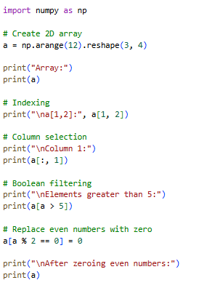
OUTPUT
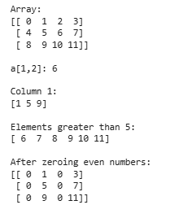
RESULT
NumPy indexing, slicing and Boolean filtering were successfully performed and verified.
EXPERIMENT 29
NumPy Statistics and Aggregation
AIM
To compute descriptive statistics such as mean, sum, standard deviation, minimum and maximum using NumPy aggregation functions.
PROCEDURE
- Import NumPy.
- Create a 2D array.
- Calculate the mean.
- Calculate column-wise sum.
- Calculate row-wise sum.
- Calculate standard deviation.
- Find minimum values.
- Find the maximum value.
INPUT
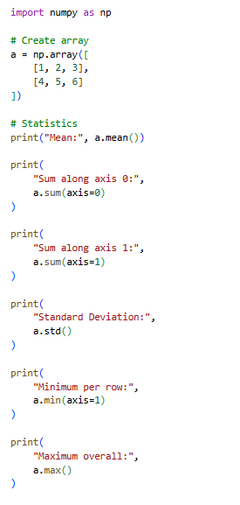
OUTPUT
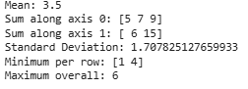
RESULT
The required statistical aggregation functions were successfully calculated.

EXPERIMENT 30
NumPy Random Module for Simulation
AIM
To generate random numbers using NumPy's random module for simulation and sampling tasks.
PROCEDURE
- Import NumPy.
- Create a seeded random number generator.
- Generate uniform random numbers.
- Generate random integers.
- Generate normally distributed numbers.
- Generate random points for Monte Carlo simulation.
- Count the points inside a unit circle.
- Estimate the value of π.
INPUT
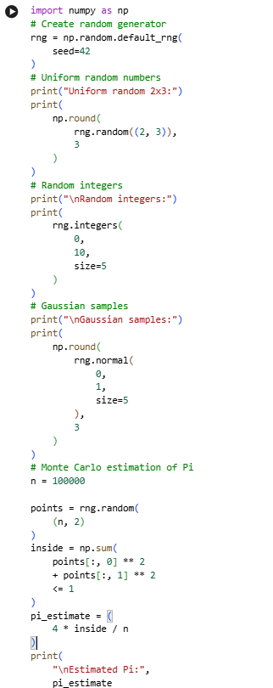
OUTPUT
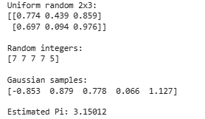
RESULT
NumPy's random module was successfully used for random sampling and Monte Carlo simulation to estimate π.

EXPERIMENT 31
Saving and Loading Data with NumPy
AIM
To save NumPy arrays to disk in binary and text formats and reload them for later use.
PROCEDURE
- Import NumPy.
- Create a NumPy array.
- Save the array in .npy binary format.
- Save the array in CSV text format.
- Load the .npy file.
- Load the CSV file.
- Display the loaded arrays.
INPUT
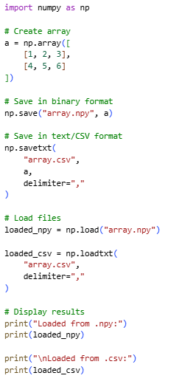
OUTPUT
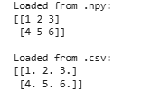
RESULT
The NumPy array was successfully saved and reloaded in both binary (.npy) and text (.csv) formats.
EXPERIMENT 32
Pandas DataFrame Creation and Combining
AIM
To create Pandas DataFrames from dictionaries and combine them using concatenation and merging.
PROCEDURE
- Import Pandas.
- Create two DataFrames.
- Concatenate the DataFrames.
- Create another DataFrame containing grades.
- Merge the DataFrames using a common column.
- Display the results.
INPUT
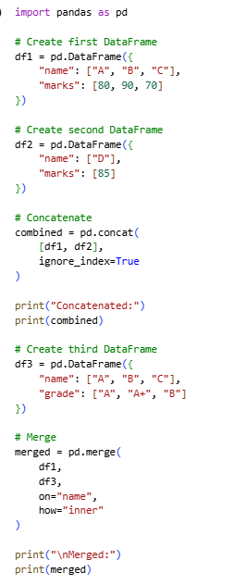
OUTPUT
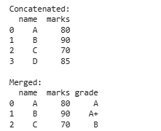
RESULT
The Pandas DataFrames were successfully created, concatenated and merged using a common key.

EXPERIMENT 33
Pandas File I/O
AIM
To read data from a CSV file into a DataFrame, process it and write the processed DataFrame into a new CSV file.
PROCEDURE
- Create sample student data.
- Save it as a CSV file.
- Read the CSV file using Pandas.
- Create a new pass column.
- Check whether marks are greater than or equal to 50.
- Save the processed DataFrame.
- Display the result.
INPUT
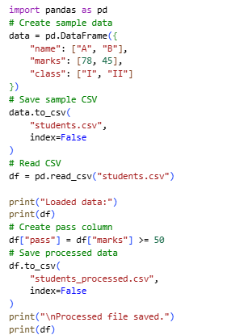
OUTPUT
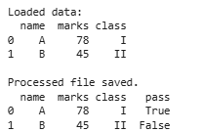
RESULT
CSV file I/O was successfully performed, including reading, processing and writing data.
EXPERIMENT 34
Pandas Grouping and Aggregation
AIM
To group data by a categorical column and calculate aggregate statistics for each group.
PROCEDURE
- Import Pandas.
- Create a DataFrame containing classes and marks.
- Group the data by class.
- Calculate the mean marks.
- Calculate mean, maximum and minimum marks.
- Display the results.
INPUT
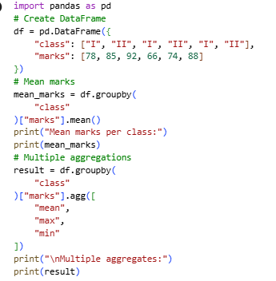
OUTPUT
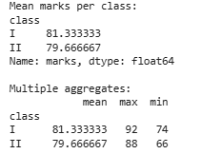
RESULT
Grouping and multi-statistic aggregation were successfully performed on the dataset.
EXPERIMENT 35
Pandas Filtering and Sorting
AIM
To filter DataFrame rows based on conditions and sort the results by one or more columns.
PROCEDURE
- Import Pandas.
- Create a student DataFrame.
- Filter students whose marks are greater than 70 and belong to Class I.
- Sort the data by class and marks.
- Display the filtered and sorted DataFrames.
INPUT
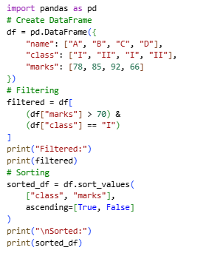
OUTPUT
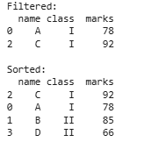
RESULT
Multi-condition filtering and multi-column sorting were successfully applied to the DataFrame.

EXPERIMENT 36
Pandas Plotting / Data Visualisation
AIM
To visualise DataFrame data using Pandas' built-in plotting functions by creating a bar chart and histogram.
PROCEDURE
- Import Pandas and Matplotlib.
- Create a DataFrame containing student marks.
- Create a histogram of marks.
- Save the histogram.
- Create a bar chart of student marks.
- Save the bar chart.
- Display confirmation.
INPUT
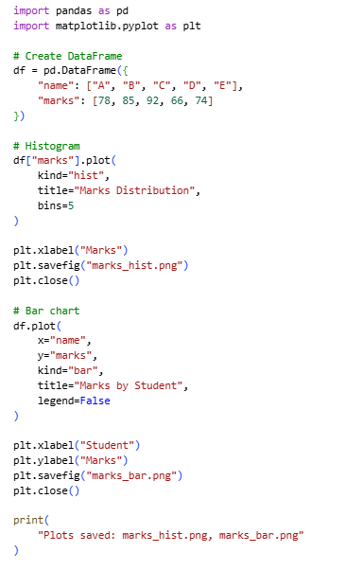
OUTPUT
RESULT
A histogram and bar chart were successfully generated for visualising the student marks.
EXPERIMENT 37
Data Cleaning with Pandas
AIM
To identify and handle missing values and duplicate records in a dataset using Pandas.
PROCEDURE
- Import Pandas and NumPy.
- Create a DataFrame containing missing values.
- Detect missing values using isnull().
- Fill missing values using fillna().
- Identify and remove duplicate records.
- Display the cleaned dataset.
INPUT
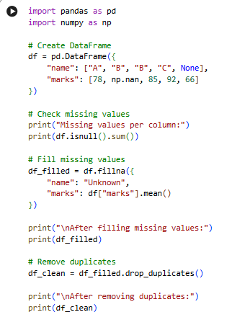
OUTPUT
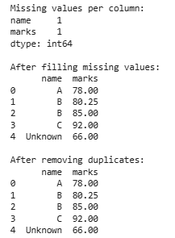
RESULT
Missing values were successfully identified and filled, and duplicate records were handled to produce a cleaner dataset.
EXPERIMENT 38
End-to-End Mini ML Pipeline
AIM
To build a complete mini machine-learning pipeline involving data loading, cleaning, preprocessing, training and prediction using a KNN classifier.
PROCEDURE
- Load the Iris dataset.
- Create a Pandas DataFrame.
- Handle missing values.
- Encode the categorical target.
- Split the data into training and testing sets.
- Standardise the features.
- Train a KNN classifier.
- Predict the test data.
- Calculate accuracy.
- Display sample predictions.
INPUT
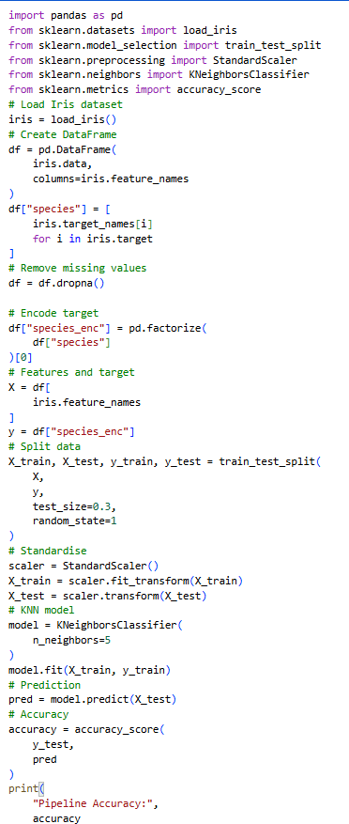
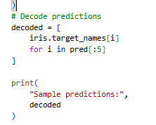
OUTPUT
RESULT
A complete data-loading-to-prediction ML pipeline was successfully implemented, achieving approximately 97.8% classification accuracy.

EXPERIMENT 39
Model Evaluation Metrics
AIM
To compute and interpret standard classification evaluation metrics such as confusion matrix, accuracy, precision, recall and F1-score.
PROCEDURE
- Load the Iris dataset.
- Split it into training and testing sets.
- Create a Decision Tree classifier.
- Train the classifier.
- Generate predictions.
- Calculate the confusion matrix.
- Calculate accuracy.
- Calculate precision, recall and F1-score.
- Display the results.
INPUT
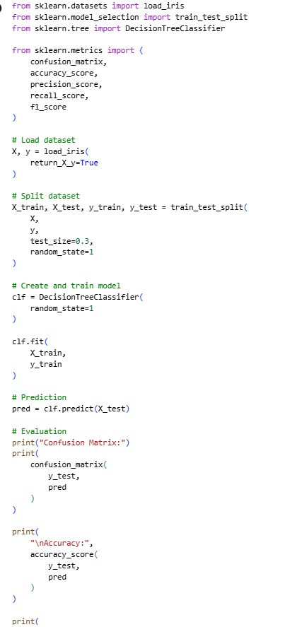
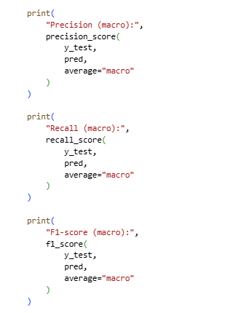
OUTPUT
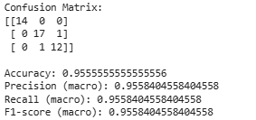
RESULT
The standard classification evaluation metrics were successfully calculated. The manual reports approximately 95.56% accuracy, with macro precision, recall and F1-score also around 0.956.

EXPERIMENT 40
Complete Machine Learning Pipeline with Visualisation
AIM
To integrate NumPy, Pandas, machine learning and visualisation into one complete end-to-end machine-learning pipeline.
PROCEDURE
- Load the Iris dataset.
- Create a Pandas DataFrame.
- Explore the dataset.
- Separate features and target.
- Split the data into training and testing sets.
- Train a Decision Tree model.
- Train a KNN model.
- Calculate accuracy for both models.
- Compare the model performances.
- Create a bar chart of model accuracies.
INPUT
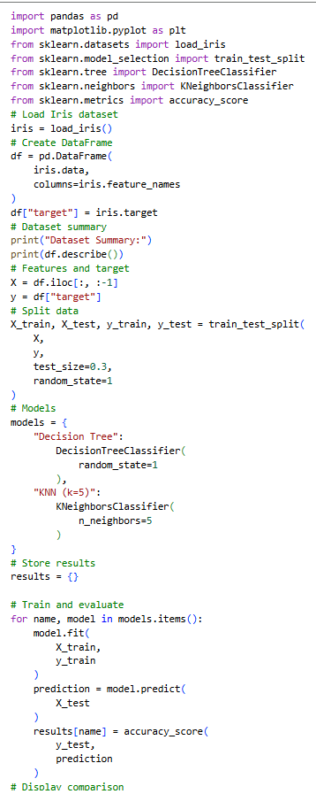
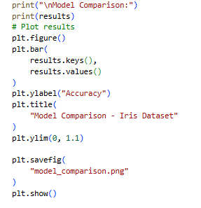
OUTPUT
RESULT
The complete machine-learning pipeline was successfully implemented, including data exploration, model training, evaluation and visualisation.

